Summer 2018 Introduction to Business Class:
To login:
https://ccsf.instructure.com/
As a CCSF student, you should automatically have a Canvas account. You should also be able to see the course for which you registered.

When you first navigate to ccsf.instructure, you will be redirected to the RAM ID Login page. You can login there and access the summer course, click on the WileyPlus Learning Space link in the course, accept terms, then choose the registration option that’s right for you (book purchase).

Click on WileyPlus Learning Space Home Page Link, you will have purchasing options and registration screen.
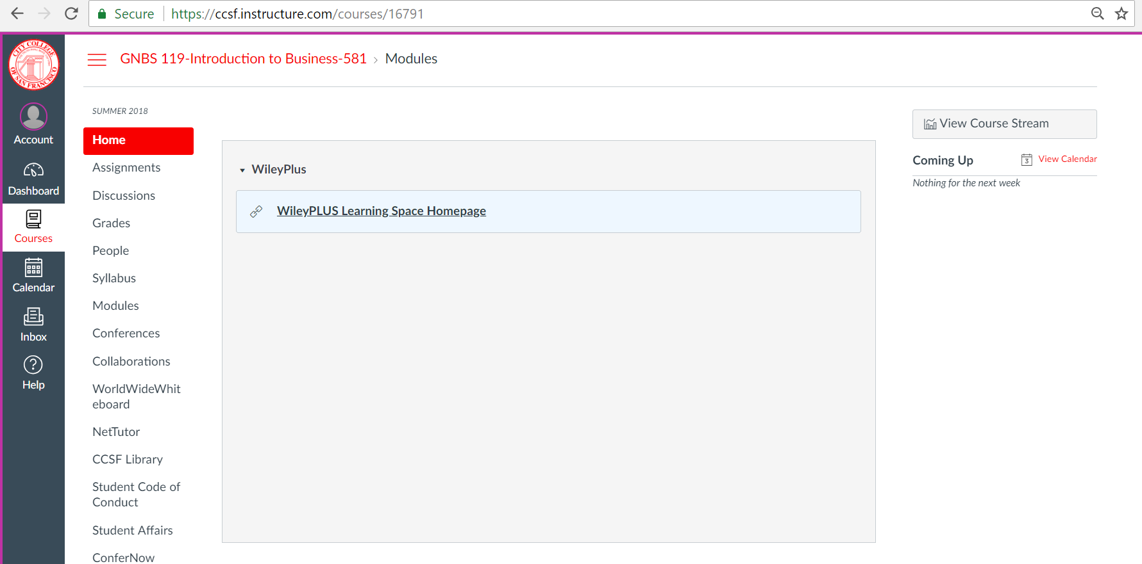

Agree to terms:
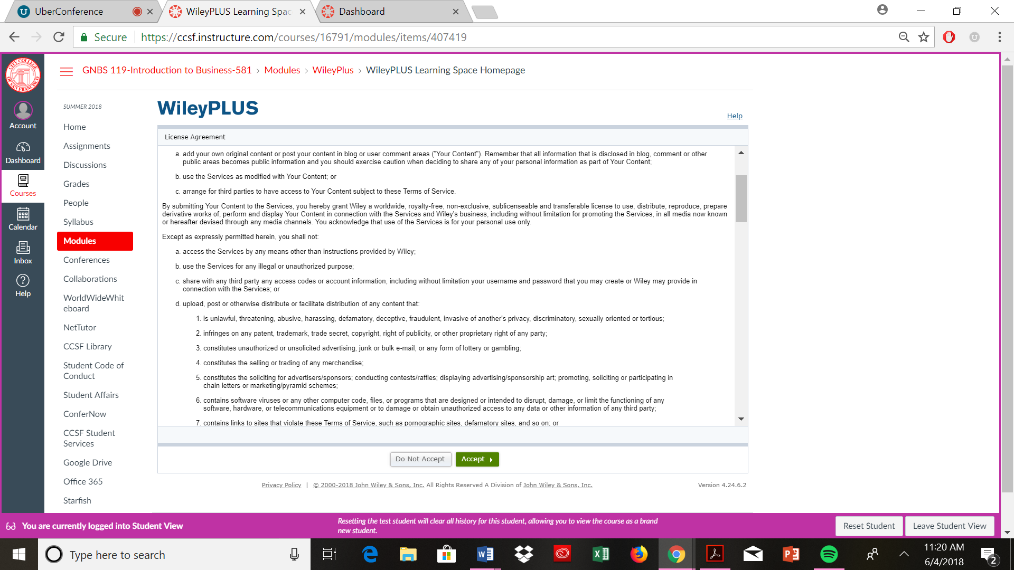

Purchasing Options:
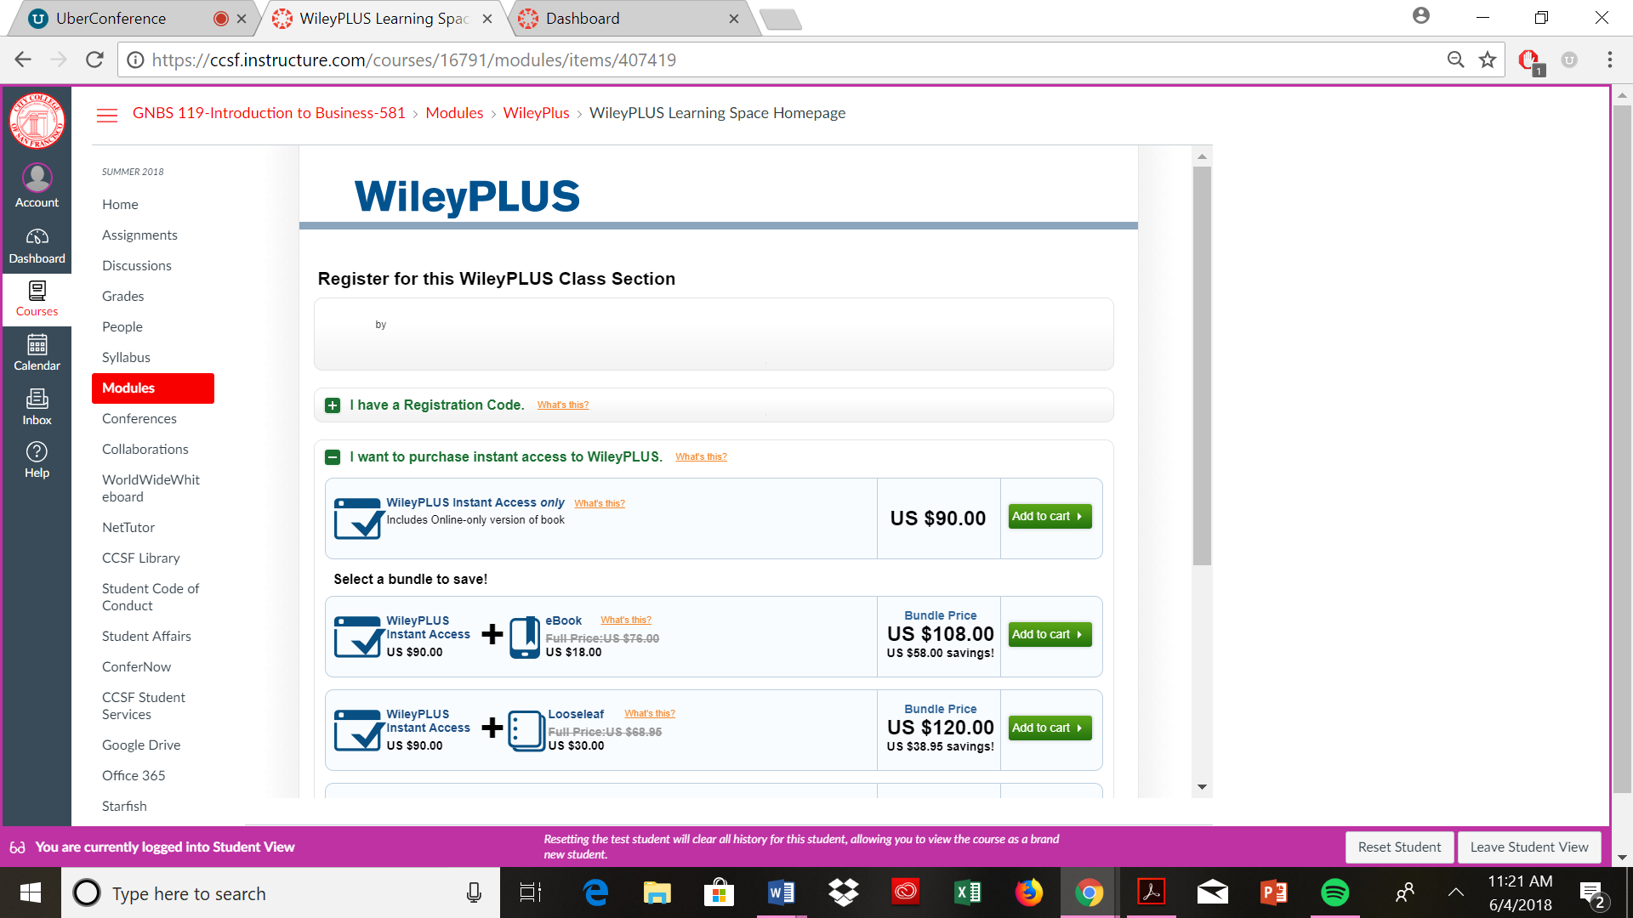

If you purchased the book in the bookstore, you will have a registration code, so use that:

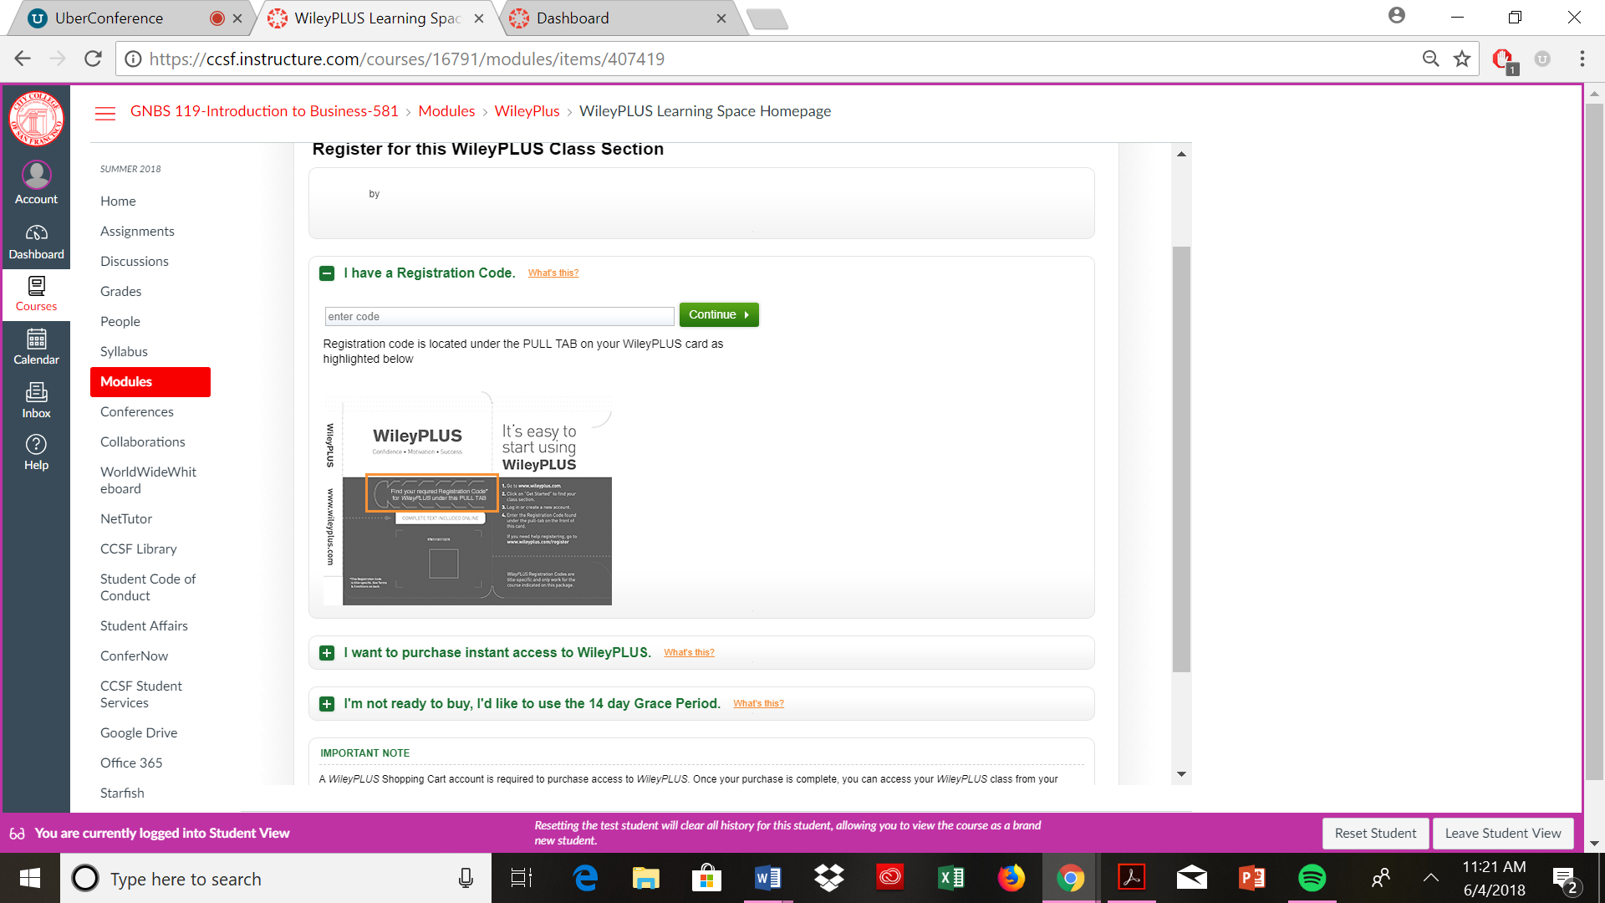

Please get started Reading the first chapter and complete the online homework, due 6/14, by 11 pm.
We will discuss how to complete the homework in the first class.

Thanks!

Ms. B

