GNBS Honors
Final Write-up

The individuals I worked with are Brett and Jack. Brett is the accountant and his email is Jack is the executive director and his email is. Both are helpful in giving me access to resources even though we telecommute. Our main platform of communication is Gmail. Before starting the project, Jack and I met to determine our goals and terms of communication. There was not much of face-to-face communication. I was self-managed. I did research in October, reviewed financials in November, and set up QuickBooks and wrote a budget report in December.
Because this is my first time doing an accounting project, I was intimidated by the uncertainty. I have never heard of the program QuickBooks and I was still in my first accounting class so other than basic journal entries, I could not do much. My expectations were to learn more about the financial statements of a non-profit organization and to accomplish the main goal of establishing a foundational QuickBooks set-up so TurnOut can track its expenses and create budget forecasts easily. I sent Jack and Brett a budget report yesterday and I finished setting up QuickBooks with the transactions stated in the excel file. Overall, I am very proud of how the project ends. The main goals are met because Jack and I wanted to figure out how QuickBooks can cater to TurnOut’s needs. To exceed these basic goals, we are going to tie loose ends in the new year. By then, Jack and Brett will have analyzed my work to see ways we could improve to develop an efficient way to keep records.
This semester was challenging because I took many classes. I knew I would not be able to do extracurricular activities because of the school work. However, when I took on this project, I learned how to utilize my time-management skills. Every week, I dedicate my time to research or review statements and every Friday, after my class ends at 1, I go to the library to write a weekly update. The best thing I got out of this was communications. I love communicating via email because it is more comprehensive than it is on the phone. Having conversations about finances is difficult without pinpointing what I want to ask about. Gradually, I was improving my formal writing skills as I sent emails to Jack and Brett. Looking at the real data from a company allows me to apply theoretical knowledge of accounting to a practical area. Having a weekly deadline keeps me on track. I have a to-do list of tasks to accomplish and honor’s update is one. Meeting deadlines is a significant skill to have because workplace requires us to be reliable enough to meet deadlines and bigger goals.
This project was beneficial because it was a self-managed process. It was an ongoing process. The challenge was to keep myself on track because once I miss a weekly update, I am off the chart. This is an incentive and working towards accomplishing a goal is very rewarding, especially when it comes to gaining experience. There were times I wanted to give up because I had no guidance and doing research was in vain. During those times, I learned to diversify my sources of knowledge. I was watching YouTube videos, signing up for online webinars, and asking some people who are in advanced accounting classes.
This was my second honors project, the first one being a literary analysis paper. Doing another paper does not need human interaction at all except for the one with the professor. This GNBS honors, however, started with one. I have never been to a formal interview. Before the interview, I was nervous about what to wear or how to behave. I even dedicated an evening looking for formal attire. I seldom drink coffee so meeting Jack at a café was something new. Jack had a notebook and we were talking about how he started his organization and what its purpose is. He was noting down things that I requested and our general goal to accomplish. Looking at his organizational skills and his respectful speaking skills inspires me. He also writes emails respectfully and his emails portray him as a person. I am working to be eloquent like him in writing emails.
The main reason I accepted to take on this project is because I knew I wanted it. I have a very absurd belief that if I try enough, I can do something. It has stuck with me for a while now only to have been weakened by a few failures. I realized that learning something new is easy according to a Ted Talk that explains the 20-hour theory of dedicating 20 hours to something. This project is a 25-30 hour project and along the way, I was researching and using terms I learned in GNBS and accounting classes. I also learned many new business terms which were defined by external sources.
During the past few days, I was out of town on a road trip and I was not able to bring my laptop around. This was a decision I made because I wanted to know how some people work from afar with little to no resources. I was borrowing my friend’s computer to log on and using my phone’s Microsoft Word to do my budget analysis. While doing all those things, I realized that the smartphone is a powerful tool and I was able to download QuickBooks on my phone to use it as a guide to write my budget report. The budget report was a horizontal analysis of a partial P&L statement and some suggestions on funding. A formal budget forecast for fiscal year 2018 was created by Brett. So, I used it along with the statement of activities for fiscal year 2017 to do some analysis.
If there is one valuable thing I learned, it is my internal locus of control. While doing the project, I was strengthening my ability to manage time, communicate concisely with others, and absorbing all the new concepts of QuickBooks and general accounting principles, which are all major skills to acquire as a business major. Before writing the budget report, I had to do some research. This taught me that allocating funds and having dependable sources of income are important for a non-profit. Doing a budget analysis allows me to look at how each category of expense affects total expenses. This analytical skill is suitable to have because as a fundraising officer, I would be allocating funds and brainstorming ideas for sources of funds.
In terms of feedback, I faced some challenges. One was communication. I had communication issues because the project was mainly based on telecommuting. I would recommend not having a telecommuting project for finances/accounting because it took some time for me to get used to communicating business language via email. It is better to work in an office under supervision of people to get immediate help. It is difficult if the other end has a delay in response which can delay your work on the project because you are waiting to get a response to be able to continue the project. If it were social media and outreach, it would have been fine to telecommute. I also believe that a hands-on project is more beneficial that writing another paper. This was an honorable experience. I hope the honors project will continue to inspire many more students.

Budget Report

A good budget has cash inflows greater than cash outflows. For TurnOut, this means contributions and grants in total should exceed the expenses incurred. In other cases, loans must be taken from financial institutions to facilitate the firm’s basic operations. Overhead such as supplies and operating expenses should be covered with a reliable source of income. If they were dependent on program service revenue and are projected to operate using program service revenue but the program produces less revenue than expected, the organization will have to borrow a loan to cover operating cost. Below is a brief analysis of TurnOut’s budget based on this fiscal year’s expenses.
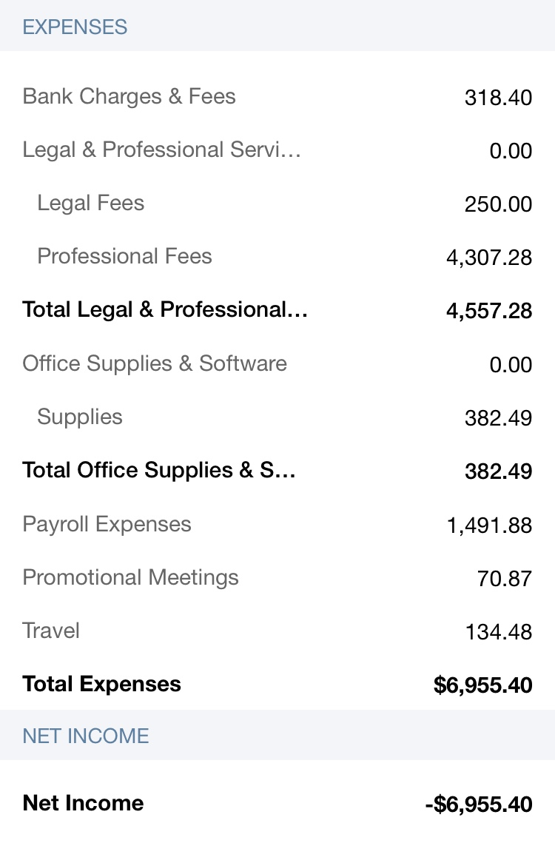
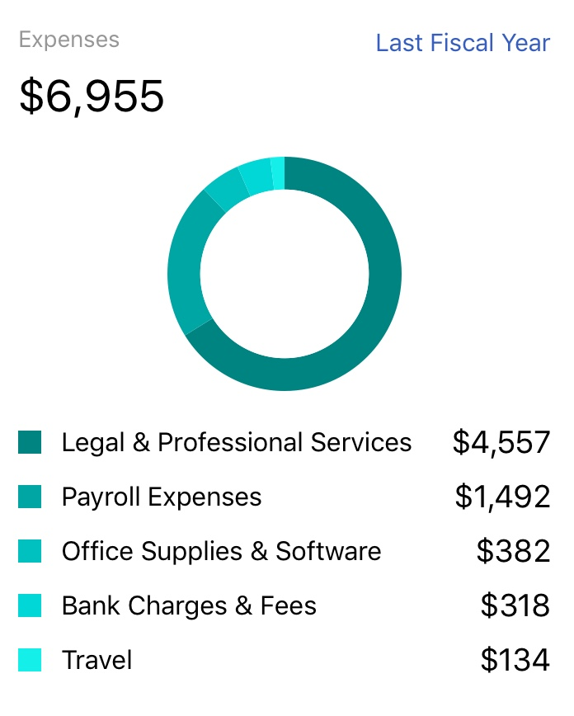
According to the chart provided by QuickBooks, Legal & Professional Services makes up 65.5% of total expenses, which is significant. Looking at a partial P&L statement at the right, the breakdown of Legal & Professional Services shows an amount of $4307.28 for Professional Fees. Professional Fees consist of all the activities that require professional services such as Airloom and Adobe. Airloom has a recurring expense of $260. Airloom is a web design service. Adobe has a recurring expense of $14.99.

Here is a horizontal analysis of the a partial P&L statement which shows details for expenses. The percentages below are based on total expenses being 100%.

Bank Charges & Fees make up 0.045%. Legal Fees make up 0.036%. Professional Fees make up 0.62%. Supplies Fees make up 0.05%. Payroll Expenses make up 0.21%. Promotional Meetings (part of Management & General functional expense) make up 0.01%. Travel (part of Program) makes up 0.02%.

According to the Statement of Activities for fiscal year ending 7/31/2017 prepared by Brett, the revenues from contributions and program service exceed the expenses incurred in program service, management & general, and fundraising. This shows a budget surplus, which is a good sign indicating a healthy budget. Change in net assets is the resulting amount of $11,378 carried to the next year. So far, TurnOut seems to be doing great with a budget plan in place. A great tip I found from research is to use one-time donations to fund events such as Hack4Equality so that if fund are lower that the forecast has predicted, regular operations are not affected. Unnecessary loans can also be prevented. Diversification of revenue sources is also crucial. I would recommend that a representative from TurnOut makes presentations at different educational institutions to recruit volunteers. For instance, non-profit organizations such as Reading Partners send representatives to reach out to students. This helps with funding because students want internship opportunities and TurnOut can use some ambitious individuals. This recruitment also applies to web design services. TurnOut has large recurring payments to Airloom for web design. There are some students wanting to apply their design skills for organizations. TurnOut can utilize the available resources to save funds with an opportunity cost of time. If done efficiently, even the manager for these recruitments can be volunteers.

It might also help to look at the predicted budget and the actual budget to find variance. A deeper understanding of the budget such as the reason on why the variance occurs can help improve accuracy of future forecasts. The reason can tell if a certain type of fundraising has financial advantage over others or if a contributor gives regular donations. Variance analysis can be used to evaluate the potential of each event or source of income. Finding the trend, as many business analysts do, is a powerful tool to create a budget that covers all fixed and variable costs and increase surplus for future purposes.

