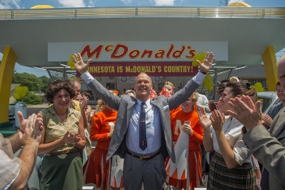
Founder Movie Guide
Themes: contracts, franchising, conflicting vision and goals.
Please answer the questions and hand this back in next week. I will be back next week. You can write directly on this sheet. One paragraph (5-7 sentences) for each question is fine.

- Why did the McDonald brothers resist franchising their business?
- Why does Ray Kroc want to renegotiate the contract with the McDonald brothers?
- How did you feel about the McDonald brothers? How did you feel about Ray? Did those feelings change throughout the movie?

- Give five examples of how Ray demonstrate perseverance.
1.

2.

3.

4.

5.
- How would you describe McDonald’s role in American society today? How has its role changed over the years and what challenges has the company faced?
- Discuss the purpose and effectiveness of the tennis court scene?

